**God the Shepherd**

**Reading: Psalm 23**

The Lord is my shepherd

I will always have everything I need.

He gives me green pastures to lie in.

He leads me by calm pools of water.

He restores my strength.

He leads me on right paths to show that he is good.

Even if I walk through a valley as dark as the grave,

I will not be afraid of any danger,

Because you are with me.

Your rod and staff comfort me.

You prepared a meal for me in front of my enemies.

You welcomed me as an honoured guest.

My cup is full and spilling over.

Your goodness and mercy will be with me all my life,

And I will live in the Lord’s house a long, long time.

**Thought about the reading**

The reading today is a psalm, or song which was written by King David a long time ago. He says that God is like a shepherd. A shepherd looks after his sheep. He feeds them, finds them water, keeps them safe and leads them to green fields.

Jesus said he is the Good Shepherd. He is like the shepherd that David describes. He gives us what we need, he leads us in the right path. He keeps us safe even in dark places. He will lead us to heaven at last where he will welcome us like special guests.

**Prayer**

Lord Jesus, thank you that you are the Good Shepherd. You look after me and keep me safe. Help me to follow you like the sheep follow their shepherd.

Amen

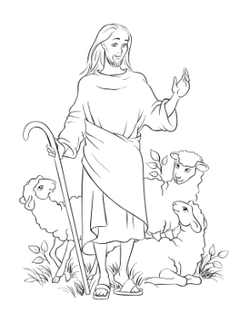

**Cambridge Causeway**

Spring 2022

Bible Study notes

**Names of God**

**3. God the Shepherd**

By Chrissy Cole